Project Report for Computer Networks 18CSC302J

**Bank Network Design**

**By :**

**-Ratnangsu Chatterjee (RA1911031010091)**

**-Harsh Tiwari (RA1911031010080)**

**-Tanya Jayanti (RA1911031010074)**

**Report Contents:**

1. Project title with team details

1. Project Abstract and Introduction

1. Motivation
2. Design Architecture
3. Campus diagram
4. Network requirement analysis (Understanding the hardware and quantity required to setup the network)
5. Network diagram with appropriate components (Includes the make and model number of required hardware)
6. Network and system integration methodology
7. IP network design guidelines (Guidelines for IP address management and usage on the network)
8. Features and Services (The services and features required to be setup and configured on the identified hardware for the solution to work)

1. Bill of material (Includes equipment, model and quantity)
2. Conclusion

**Project Abstract and Introduction:**

During the last decade, the importance of computer networks and telecommunications has grown tremendously .A computer network is a set of [computers](https://en.wikipedia.org/wiki/Computer) sharing resources located on or provided by [network nodes](https://en.wikipedia.org/wiki/Node_(networking)). These interconnections are made up of [telecommunication network](https://en.wikipedia.org/wiki/Telecommunication_network) technologies, based on physically wired, optical, and wireless radio-frequency methods that may be arranged in a variety of [network topologies](https://en.wikipedia.org/wiki/Network_topology).

In this project, we are designing computer network for a bank. The initiative steps were taken by the American and British banks. In banks, computers are used for keeping account information of customer accounts.Computers help bankers keep a record of and verify financial records much quicker.

The general aim of this project is to simulate a banking network which is secure and easy to use. The computers in a bank will be able to communicate with each other to form a network to exchange information regarding customer accounts, transactions etc. The project is being implemented through the Cisco Packet Tracer software.

This bank network consists of the following devices:

1) Router (1941)

2) Switches (2960-24TT)

3) Email server

4) DNS server

5) WEB server (HTTP)

6) Wireless Device (Access Point)

7) PCs

8) Laptops

9) Smartphones

**MOTIVATION:**

The word “digital” is very significant in today’s world, with an increase in the development of technology the entire world is moving towards the digital era. Going wireless plays an important role in this digitalization. The wireless network makes the connection easy with a reduction in the use of wires or cables. A wired connection makes it difficult to keep track of all the devices and to manage the cable connection, which is not only chaotic but also challenging to handle.

Networking is a vast concept and being a part of contributing to the design of safe networking in a bank is a task we would like to accomplish. I believe my team has the capability and experience to deliver this and ensure that the network is functional properly and can be used with ease.

**Design Achitecture:**

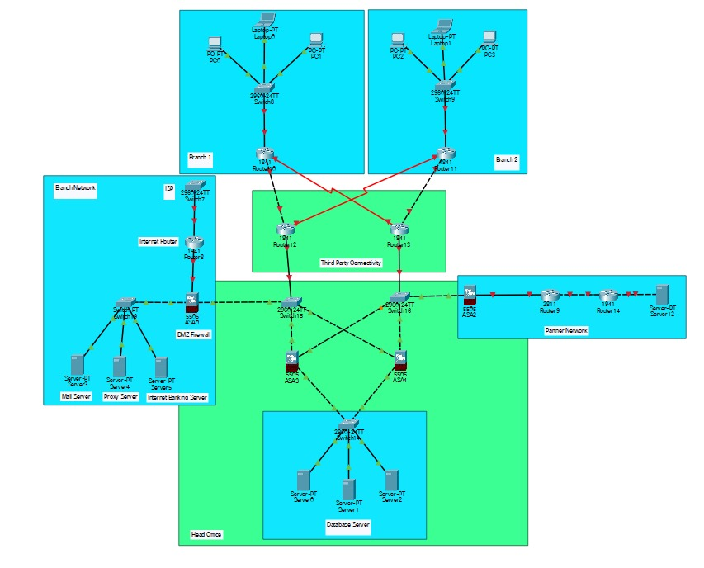

**Campus Diagram:**

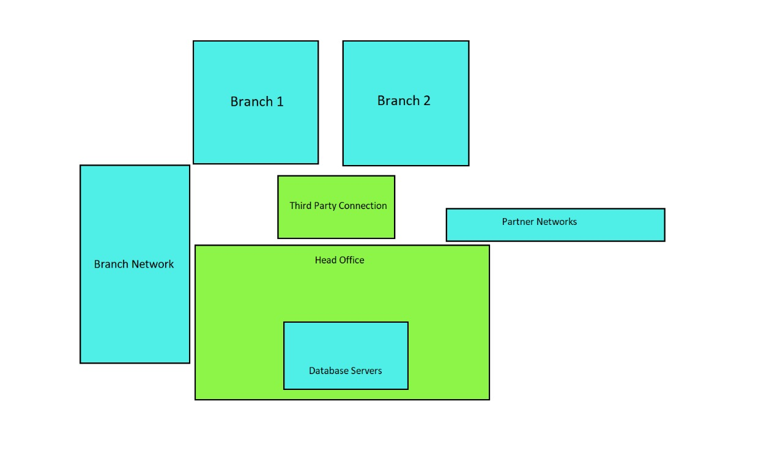

**Network Requirement Analysis:**

This bank network consists of the following devices:

1. Router:

* 1941(x2):

The Cisco 1941 **Integrated Services Router** (ISR) delivers highly secure data, mobility, and application services. Key features include: 2 integrated 10/100/1000 Ethernet ports. 2 enhanced High-Speed WAN Interface Card slots that can host 2 single wide or 1 double wide and 1 single wide HWIC.

* 1841(x4):

The Cisco 1841 router features secure, fast, and high-quality delivery of multiple, concurrent services for small-to-medium-sized businesses and small enterprise branch offices. The Cisco 1841 router offers embedded hardware-based encryption enabled by an optional Cisco IOS Software security image; further enhancement of VPN performance with an optional VPN acceleration module; an intrusion prevention system (IPS) and firewall functions; interfaces for a wide range of connectivity requirements, including support for optional integrated switch ports; plus sufficient performance and slot density for future network expansion and advanced applications as well as an integrated real-time clock.

* 2811(x1)

The Cisco 2811 router is a multiple-chip standalone cryptographic module. The router has a processing speed of 350MHz. ... The cryptographic boundary of the module is the device's case. All of the functionality discussed in this document is provided by components within this cryptographic boundary.

1. Switches:

* 2960-24TT(x5)

Cisco Catalyst 2960 Series Switches with LAN Lite software are fixed-configuration, standalone switches that provide desktop Fast Ethernet connectivity for entry-level wiring closet and small branch-office networks

* PT Switch(x1)

A network switch—not to be confused with a light switch or a Nintendo Switch—is a box that you connect to your home router to gain more Ethernet ports. Think of it as functioning like a USB hub but for networking.

1. Servers:

* Email(x1)

An email server, is an application or computer in a network whose sole purpose is to act as a virtual post office.

* Proxy Server(x1)

A proxy server provides a gateway between users and the internet. It is a server, referred to as an “intermediary” because it goes between end-users and the web pages they visit online.

1. Firewalls(x4):

A firewall is a network security device that monitors incoming and outgoing network traffic and permits or blocks data packets based on a set of security rules. Its purpose is to establish a barrier between your internal network and incoming traffic from external sources (such as the internet) in order to block malicious traffic like viruses and hackers.

1. PCs(x6)

**Network Requirement Analysis:**



This bank network consists of the following devices:

1) Router (1941)

2) Switches (2960-24TT)

3) Email server

4) DNS server

5) WEB server (HTTP)

6) Wireless Device (Access Point)

7) PCs

8) Laptops

9) Smartphones

**Network and system integration methodology:**

The most common integration process is the Application Programming Interface (API). While there are several API subcategories, including public, private, and partners, they all utilize application integration. By establishing these interconnections using common code language, systems can transmit data seamlessly throughout solutions.

**Advantages:**

Flexibility - By using product code language, the API method can handle most data variations.

Smooth Operations - The links between the systems allow providers to handle individual connections without disturbing third-party software.

High Availability - As the most common integration strategy, API is available for almost every integration project.

**Disadvantages:**

Supplier Dependability - Suppliers are responsible for establishing an API, making the partnering business dependent on their schedule for data access.

Code Intensive - While being code-based makes APIs more functional, programming the coding is time-intensive and can be overwhelming.

**IP network design guidelines:**

• ENABLE : To go in priviledge mode

• CONFIGURE TERMINAL : To go in global configuration mode

• ENABLE PASSWORD : To give password

• ENABLE SECRET : To give secret password

• LINE CONSOLE 0 : To go in line console mode

• EXECUTION TIMEOUT 0 : To make console never go to sleep in line console mode

• LOGGING SYNCHRONOUS : To avoid the messages it also run in line console mode

• SHOW RUNNING CONFIGURATION:

• SHOW IP INTERFACE BRIEF : To show the IP configuration

• INTERFACE FASTETHERNET0/0 : To give the IP configuration of fast ethernet

• INTERFACE SERIAL0/0 : To give the IP configuration of serial interface

• NO SHUTDOWN : To make interface up

ROUTING COMMANDS USED:

STATIC ROUTING COMMANDS:

• IN global config mode)# ip route <destination network ip> <subnet mask> <exit interface>

<permanent>

For ex.) # ip route 10.1.1.0 255.255.255.0 20.1.1.2

DEFAULT ROUTING COMMANDS:

• In global config mode)# ip route <destination network ip> <subnet mask> <exit interface>

<permanent>

For ex.) # ip route 0.0.0.0 0.0.0.0 20.1.1.2

TO CREATE VLANs:

To give name to vlan:

-config) # vlan 2 -config) # name xyz

To add interfaces to VLAN:

-config) # int fa0/0 -int) # switchport mode access -int) # switchport access vlan2

To do trunking:

-config) # int gig0/1 -int) # switchport mode trunk -int) #switchport trunk encapsulation dot1q

**Features and Services:**

1. Performance: Building Distribution switches should provide wire-speed performance on all ports. This feature is important because of Building Access layer aggregation on one side and high-speed connectivity of the Campus Core module on the other side. Future expansions with additional ports or modules can result in an overloaded switch if it is not selected properly.
2. Redundancy: Redundant Building Distribution layer switches and redundant connections to the Campus Core should be implemented. Using equal-cost redundant connections to the core supports fast convergence and avoids routing black holes. Network bandwidth and capacity should be engineered to withstand node or link failure.
3. Infrastructure services: Building Distribution switches should not only support fast multilayer switching, but should also incorporate network services such as high availability, QoS, security, and policy enforcement.Expanding and/or reconfiguring distribution layer devices must be easy and efficient. These devices must support the required management features.

**Bill of material:**

|  |  |  |  |
| --- | --- | --- | --- |
| **Tools** | **Quantity** | **Cost (per piece)** | **Total Cost** |
| Multi-Layer Switch | 5 | 20119 | 1,00,595 |
| Copper Cross Over | 7 | 810 | 5,670 |
| Copper Straight Through | 16 | 500 | 8,000 |
| Switches (Layer 3) | 7 | 164501 | 11,51,507 |
| PCs | 6 | 74990 | 4,49,940 |
| Router | 7 | 2829 | 19,803 |
| Server | 6 | 60000 | 3,60,000 |
| Firewall | 4 | 51650 | 2,06,600 |

**CONCLUSION:**

We started our discussion with the word “digitalization” and in order to achieve it, we aimed to start with an educational institute, and finally, we designed a network for a bank, which is wireless. As we mentioned, mobility and efficiency are the key aspects of wireless networks, which were our main goal, and hence, we decided to shift to a wireless network instead of a wired one, making our network clean and less chaotic.

In this project, we designed a Bank Network using Cisco Packet Tracer that uses a networking topology implemented using servers, routers, switches, and end devices in multiple area networks. We have covered all the necessary features that are required for a network to function properly. We have included a DNS server and a web server for establishing a smooth communication system between different areas of our network and specifically for the communication between students and teachers. We have included an email server to facilitate intra university communication through emails within the domain.